**Chapter 3**

***Methodology***

The first step of the methodology was the data gathering. The data for rainfall amounts every year from January 2001 to September 2012 was gathered from PAGASA Weather Station, Baguio City.

The data was then summarized and classified yearly on Microsoft Excel. However, the amount of rainfall for May 2006 was missing, so a statistical method called Bootstrapping method was done to generate a forecasted value.

Bootstrapping method is method developed by B. Efron on 1979. It is a computer-based method for assigning accurate sample estimates. This method allows estimation of the sample distribution of almost any statistic using only very simple methods (Varian 2005). Using R-statistics, a computer statistical software, bootstrapping method was used to generate an estimate for May 2006. This graph, produced from R-statistics, shows the data January 2001 to December 2005.

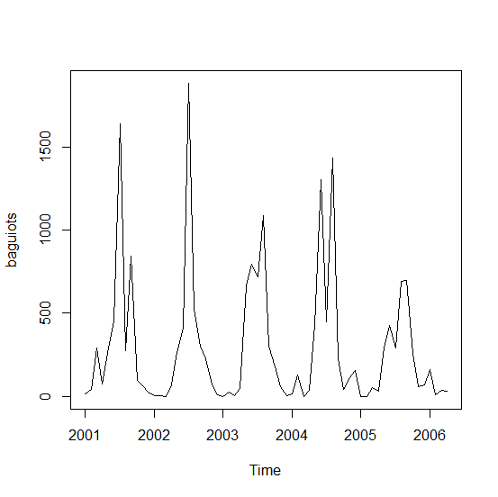 This data was used to generate an estimate for May 2006, through R-statistics, producing this graph.

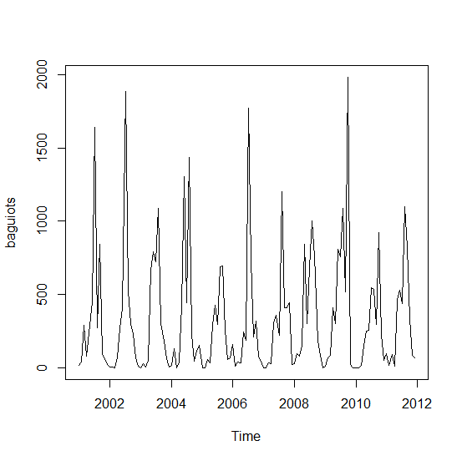

Then, a time-series analysis was conducted. A time-series analysis is a method used to obtain an understanding of the forces, which produced the data. The time series analysis is a set of data used and collected sequentially at fixed intervals of time. The amount of rainfall, the data being studied, is a time series data, which is measured and recorded at successive time intervals.

First, the complete set of data, from January 2001 to December 2011, was combined through Notepad, then saved as a “.dat” file. It was then scanned and entered to R-statistics, using the command “baguio <- scan("C:\\Users\\Computer\\Documents\\research2\\CabantacOsbucanYodong\\baguiorain.dat")”. The data was assigned to a time series variable, using the command, “baguiots <- ts(baguio,frequency=12,start=c(2001,1))”.

Baguiotsis the name of the variable, baguio is the name of the variable assigned to the original data, frequency is the frequency in a year, start assigns the starting date, 2001 was is the date assigned, and 1 pertains to the month January.

Again, using the data from January 2001 to December 2011, a forecast for January 2012 to September 2012 was generated through a different method.

First, install the forecast package by inputting the command ‘install.packages(“forecast”)’, then load the package by using the command ‘library(“forecast”)’. After loading the package, assign the data to a forecast variable, using the command, “baguioforecast2 <- forecast.HoltWinters(baguioforecast, h=1)”. Then plot the actual graph with the fitted data graph using Holt-Winters Filtering, a method used to produce a smooth graph, using the command “baguioforecast$fitted” and “plot(baguioforecast)”. This graph was then generated.



The forecasted values for January 2012 to September 2012 were then compared with the actual values for January 2012 to September 2012 using a t-test. A t-test assesses whether there are significant statistical differences between two samples.

$$t= \frac{356.3276-522.7222222}{\sqrt{\left[\frac{\left(1192724.227-\frac{({3206.9413)}^{2}}{9}\right)+ \left(6507292.93- \frac{({4704..5)}^{2}}{9}\right)}{9+9-2}\right]-\left[\frac{1}{9}+\frac{1}{9}\right]}}$$

$$t=|-0.7017419477|$$

After the t-test was accomplished, the acquired t-test value was compared to a given value from a t-distribution table. A t-distribution table contains values dependent on the degrees of freedom. In the research’s case, the degrees of freedom is 16. The df(degrees of freedom) is acquired through the formula df= (Nx-1)+(Ny-1). Nx is the number of forecasted values for January 2012 to September 2012, which is 9, and Ny is the number of actual values for January 2012 to September 2012.

According to the results of the t-test and the t-distribution, it was concluded that the forecasted values and actual values do not have significant differences.

**References**

* Kesar Singh KS, Minge Xie MX. Bootstrap: A Statistical Method. [Internet]., cited 2012 Nov 30]. Available from: <http://www.stat.rutgers.edu/home/mxie/rcpapers/bootstrap.pdf>
* Eric W. Weisstein EW. Bootsrap Methods [Internet]. MathWorld. [cited 2012 Nov 30] . Available from: <http://mathworld.wolfram.com/BootstrapMethods.html>
* What is Exponential Smoothing? [Internet]; 2003 June 01.NIST/SEMATECH; [2012 Apr 01, cited 2012 Oct 15]; Available from: <http://www.itl.nist.gov/div898/handbook/pmc/section4/pmc43.htm>
* T Distribution Critical Values Table [Internet]. [Cited 2012 Dec 10]. Available from: <http://easycalculation.com/statistics/t-distribution-critical-value-table.php>
* William MK. The T-test [Internet]; Web Center for Social Research Methods; [2006 Oct 20, cited 2012 Dec 12]. Available from: http://www.socialresearchmethods.net/kb/stat_t.php